Week 5 – Programming Challenge (Doctor Client-Server Model)

- abstract
  - *.dat
    - serialized data files that represent each client’s session
  - breezypythongui.py
    - Simplifies the user interface and event model for programmers by subclassing various classes in Python’s tkinter framework.
  - doctor.py
    - instance object hosted by doctorclienthandler to receive, iterpret, and send messages to a client
  - doctorclient.py
    - wrapped within breezypythongui
    - provides user interface to connect to doctorserver
    - sends and recieves messages from a doctor instance
  - doctorclienthandler.py
    - handles client profiles
    - hosts doctor instances
  - doctorserver.py
    - establishes connection protocol
    - listens for connections
    - manages threaded instances of doctorclienthandler

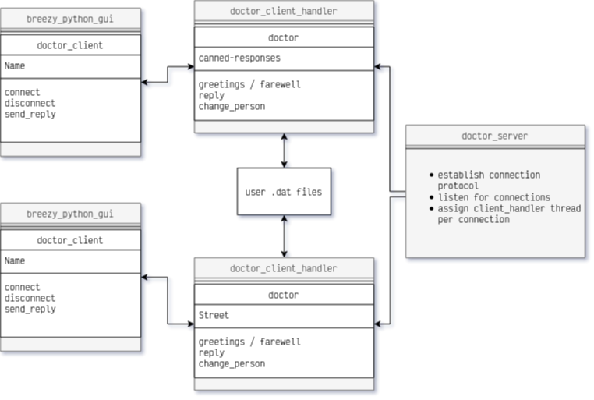
- doctor.py
  - properties
    - qualifiers
      - list of opening speech prompts
    - replacements
      - dictionary of pronouns to swap based on grammatical structure
    - hedges
      - list of continuity speech prompts
    - history
      - list of messages received from client
  - functions
    - __init__
      - establishes a history list to store messages received from the connected client
    - greeting, farewell
      - generic greeting and farewell responces to be sent to client upon connection/disconnection
    - reply
      - recieves message from client
      - processes message
      - constructs reply message
      - returns reply
    - change_person
      - used by reply to change grammatical structure/apply appropirate contextual pronoun
        - checks contents of client messages against replacements dictionary
        - modifies reply string list

- doctorclient.py inherets from breezypythongui.EasyFrame
  - properties
    - color
      - color to be assigned as the background color of the gui window
    - drLabel
      - a tkinter label populated by the doctor’s replies
    - ptField
      - a tkinter entry field used to populate user replies to the doctor
    - sendBtn
      - tkinter button used to send contents of ptField to the doctor
    - connectBtn
      - tkinter button used to send connection request
    - server
      - socket object to establish connection to doctorserver
  - functions
    - __init__
      - populates gui window with label, entry text, and buttons to interface with the doctor
      - extends text entry keyboard event functionality
    - sendReply
      - manages replies send and received by the client to the doctor by encoding/decoding a byte-stream
    - connect
      - establishes socket connection with doctorserver
      - modifies gui interface objects to reflect connected state
    - disconnect
      - closes doctorserver connection
      - modifies gui interface objects to reflect disconnected state
    - main
      - runs breezypythongui’s primary event loop with tkinter
      - this is the main execution function to start the client’s operations

- doctorclienthandler.py inherets from Thread
  - properties
    - client
      - the currently connected client’s connection
    - dr
      - a new doctor instance if the user has never connected
      - a serialized doctor instance if the user has connected
    - filename
      - a serialized file representing a client’s session and doctor
  - functions
    - __init__
      - instantiates a new threaded process of doctorclienthandler
      - assigns itself the connected client
    - run
      - special function for threaded processes (invoked by calling .start() on object)
      - pulls client .dat file if one exists
      - creates new doctor instance if one doesn’t
      - sends greeting
      - allows doctor instance to communicate with client
      - continues allowing communication until user interrupts by disconnecting
      - saves doctor-client interactions in serialized .dat file

- doctorserver
  - globals
    - host
      - IP address designated to receive connections
    - port
      - port within IP address to receive connections
    - address
      - tuple assigned to bind host and port
    - server
      - socket instance with connection protocol (Ipv4) and communication protocol (streaming)
  - function
    - continually listen for incoming connections
    - establish a new threaded process for each connected client handled by a doctorclienthandler

